**DEPARTMENT OF COMPUTER & SOFTWARE ENGINEERING**

**COLLEGE OF E&ME, NUST, RAWALPINDI**

**CS474 Computer Vision (Elective)**

Lab # 02: Digital Image Processing using Python and OpenCV

|  |  |
| --- | --- |
| **Name** | Muhammad Hashir Ashraf |
| **Registration Number** | 408557 |
| **Degree/ Syndicate** | 44/ B |
| **Instructor’s Name** | LE Sardar Umair |

# Objectives:

# • To introduce students with python programming language

# • Install PyTorch and understand its basic structure.

# • Learn about tensors and basic tensor operations.

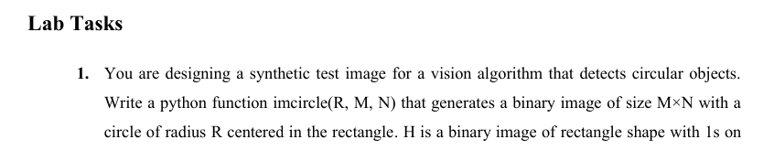

## **Code:**

import numpy as np

import cv2

def imcircle(R, M, N):

    cy, cx = M // 2, N // 2

    if (cx - R < 0 or cx + R >= N or cy - R < 0 or cy + R >= M):

        print(f"Error: A circle with radius {R} does not fit in a {M}x{N} rectangle.")

        return None

    image = np.zeros((M, N), dtype=np.uint8)

    for i in range(M):

        for j in range(N):

            if (j - cx)**2 + (i - cy)**2 <= R**2:

                image[i, j] = 1

    return image

binary_circle = imcircle(100, 300,400)

if binary_circle is not None:

    cv2.imshow('Circle Task', binary_circle * 255)

    cv2.waitKey(0)

    cv2.destroyAllWindows()

## **Output:**

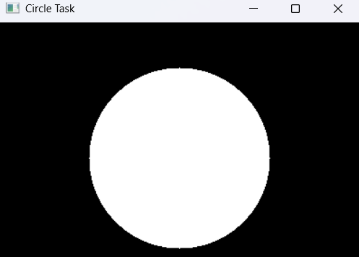

**Figure 1**

## **Code:**

import cv2

img = cv2.imread('4278.jpg')

cv2.imshow('Original Image', img)

cv2.waitKey(0)

target_width = 800

target_height = 600

resized_image = cv2.resize(img, (target_width, target_height))

text = "CV LAB 2"

font = cv2.FONT_HERSHEY_SIMPLEX

cv2.putText(resized_image, text, (300, 300), font, 1.5, (255, 255, 255), 2)

cv2.imshow('', resized_image)

cv2.waitKey(0)

gray_image = cv2.cvtColor(resized_image, cv2.COLOR_BGR2GRAY)

cv2.imshow('', gray_image)

cv2.waitKey(0)

threshold_value = 200

ret, binary_image = cv2.threshold(gray_image, threshold_value, 255, cv2.THRESH_BINARY)

cv2.imshow('', binary_image)

cv2.waitKey(0)

cv2.destroyAllWindows()

**Output:**

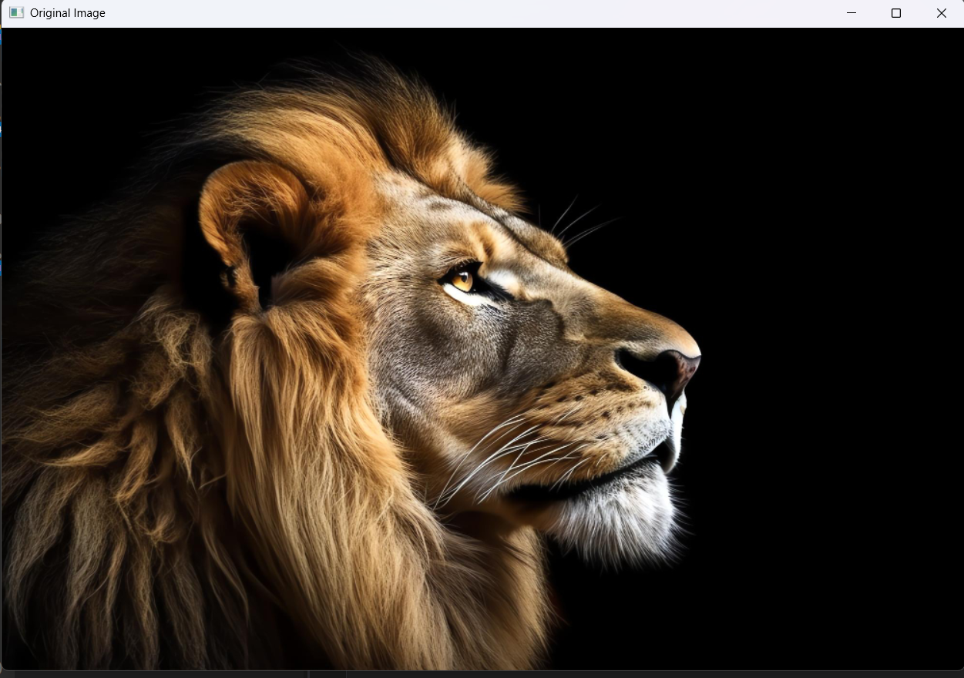

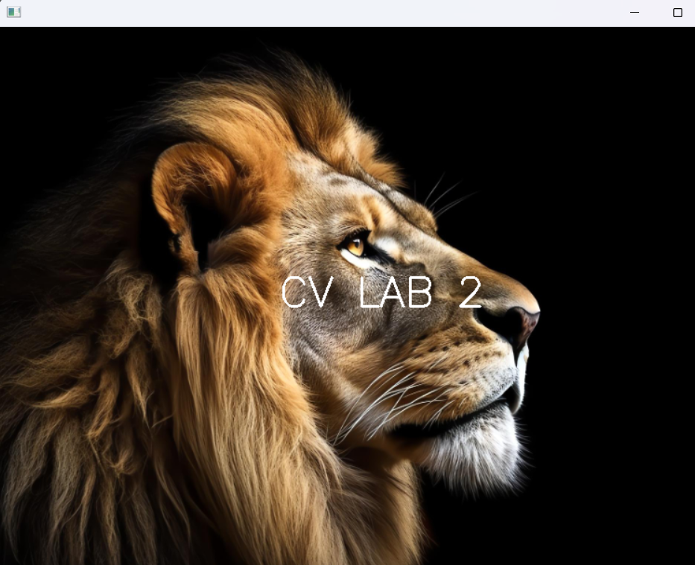

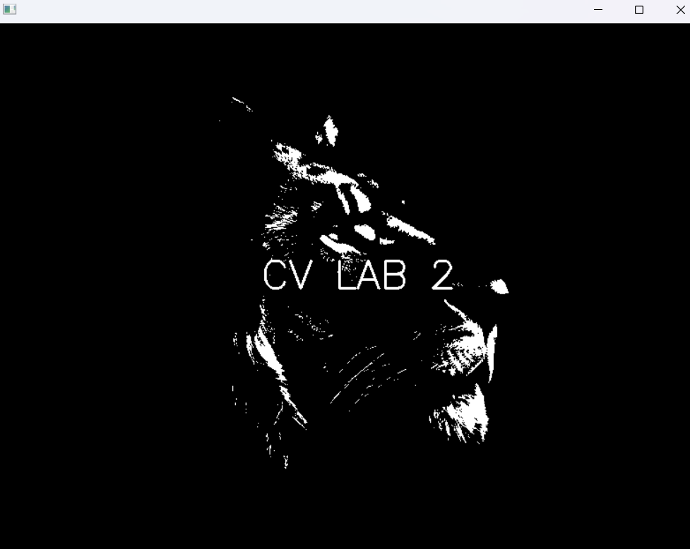

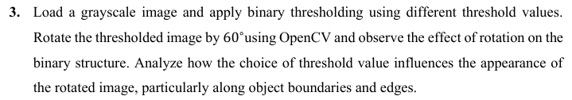

**Code:**

import cv2

img = cv2.imread('4278.jpg')

cv2.imshow('Original Image', img)

cv2.waitKey(0)

gray_image = cv2.cvtColor(img, cv2.COLOR_BGR2GRAY)

cv2.imshow('', gray_image)

cv2.waitKey(0)

threshold_value = 140

ret, binary_image = cv2.threshold(gray_image, threshold_value, 255, cv2.THRESH_BINARY)

cv2.imshow('', binary_image)

cv2.waitKey(0)

rotation_matrix = cv2.getRotationMatrix2D((binary_image.shape[1] / 2,binary_image.shape[0] / 2), 60, 1)

rotated_image = cv2.warpAffine(binary_image, rotation_matrix, (binary_image.shape[1], binary_image.shape[0]))

cv2.imshow('', rotated_image)

cv2.waitKey(0)

cv2.destroyAllWindows()

**Output:**

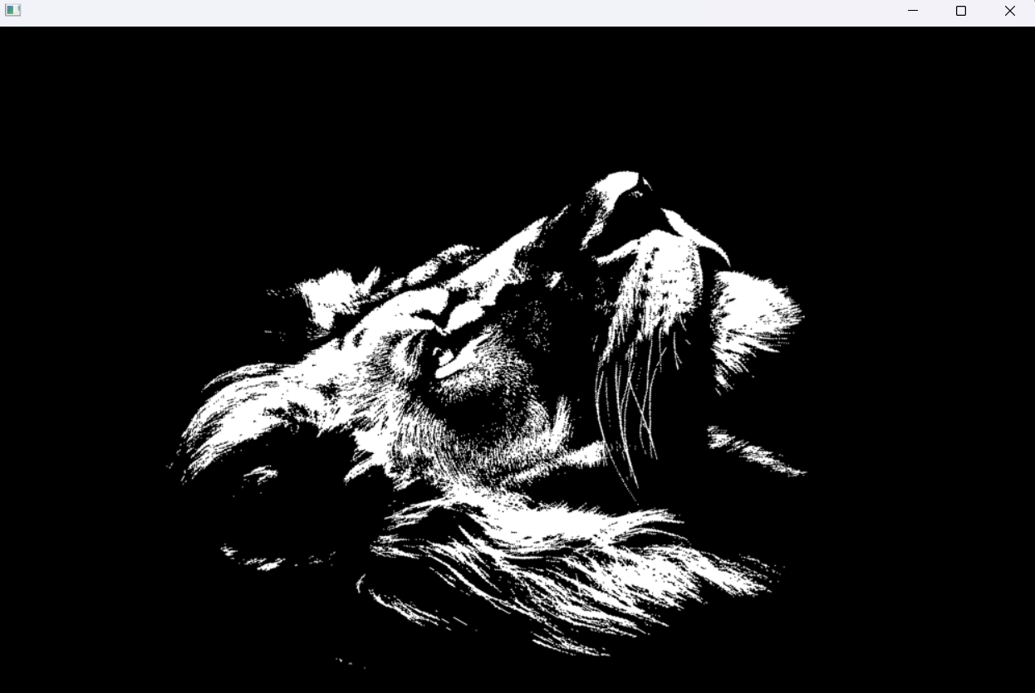

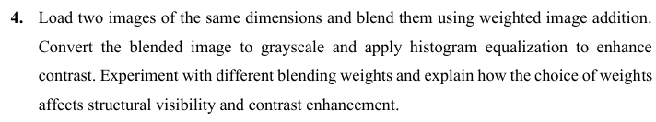

**Code:**

import cv2

import numpy as np

img1 = cv2.imread('4278.jpg')

img2 = cv2.imread('q2.jpg')

img2 = cv2.resize(img2, (1280, 720))

image1 = cv2.resize(img1, (img2.shape[1], img2.shape[0]))

alpha = 0.7

beta = 0.3

gamma = 0

blended_image = cv2.addWeighted(image1, alpha, img2, beta, gamma)

cv2.imshow('Weighted Blend', blended_image)

cv2.waitKey(0)

gray_image = cv2.cvtColor(blended_image, cv2.COLOR_BGR2GRAY)

cv2.imshow('Grayscale Blend', gray_image)

cv2.waitKey(0)

equalized_image = cv2.equalizeHist(gray_image)

cv2.imshow('Equalized Image', equalized_image)

cv2.waitKey(0)

cv2.destroyAllWindows()

**Output:**

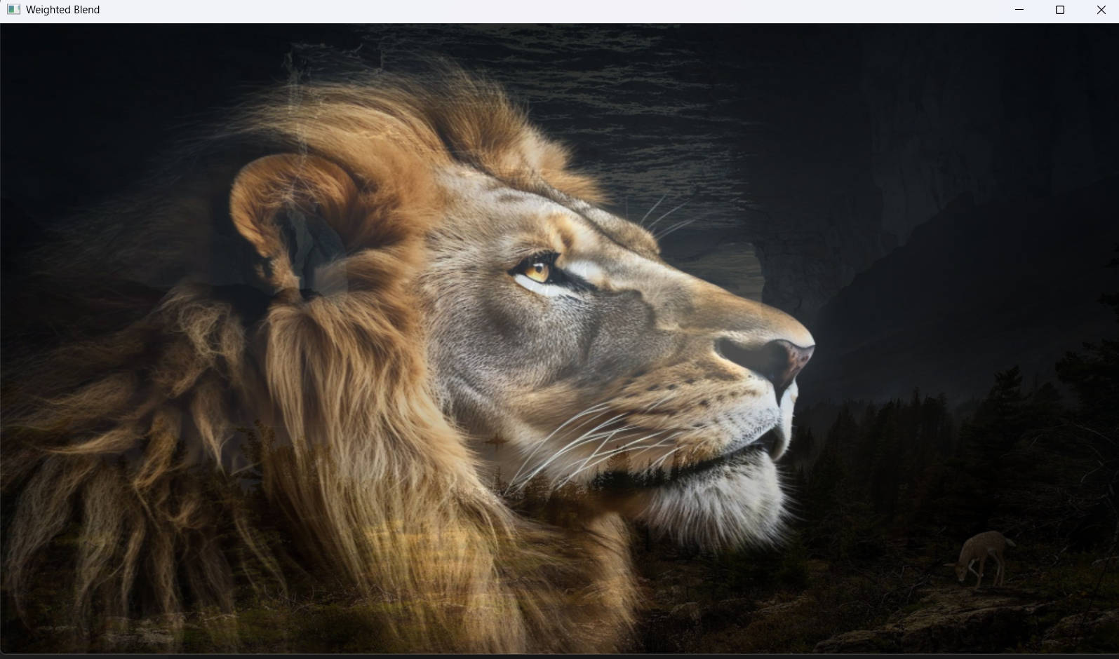

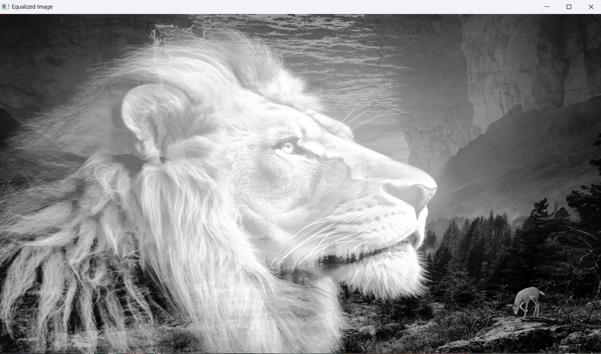

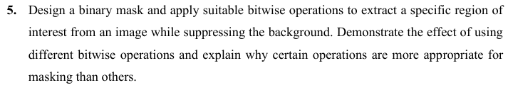

**Code:**

import cv2

import numpy as np

img1 = cv2.imread('spider.jpg')

image1 = cv2.resize(img1, (1280,720))

cv2.imshow('', image1)

cv2.waitKey(0)

cv2.destroyAllWindows()

mask = np.zeros(image1.shape[:2], dtype=np.uint8)

cv2.rectangle(mask, (340,100), (1070, 720), 255, -1)

extracted_roi = cv2.bitwise_and(image1, image1, mask=mask)

extracted_roi2 = cv2.bitwise_not(image1, image1, mask=mask)

extracted_roi3 = cv2.bitwise_or(image1, image1, mask=mask)

extracted_roi4 = cv2.bitwise_xor(image1, image1, mask=mask)

cv2.imshow('', extracted_roi)

cv2.waitKey(0)

cv2.imshow('', extracted_roi2)

cv2.waitKey(0)

cv2.imshow('', extracted_roi3)

cv2.waitKey(0)

cv2.imshow('', extracted_roi4)

cv2.waitKey(0)

cv2.destroyAllWindows()

**Output:**

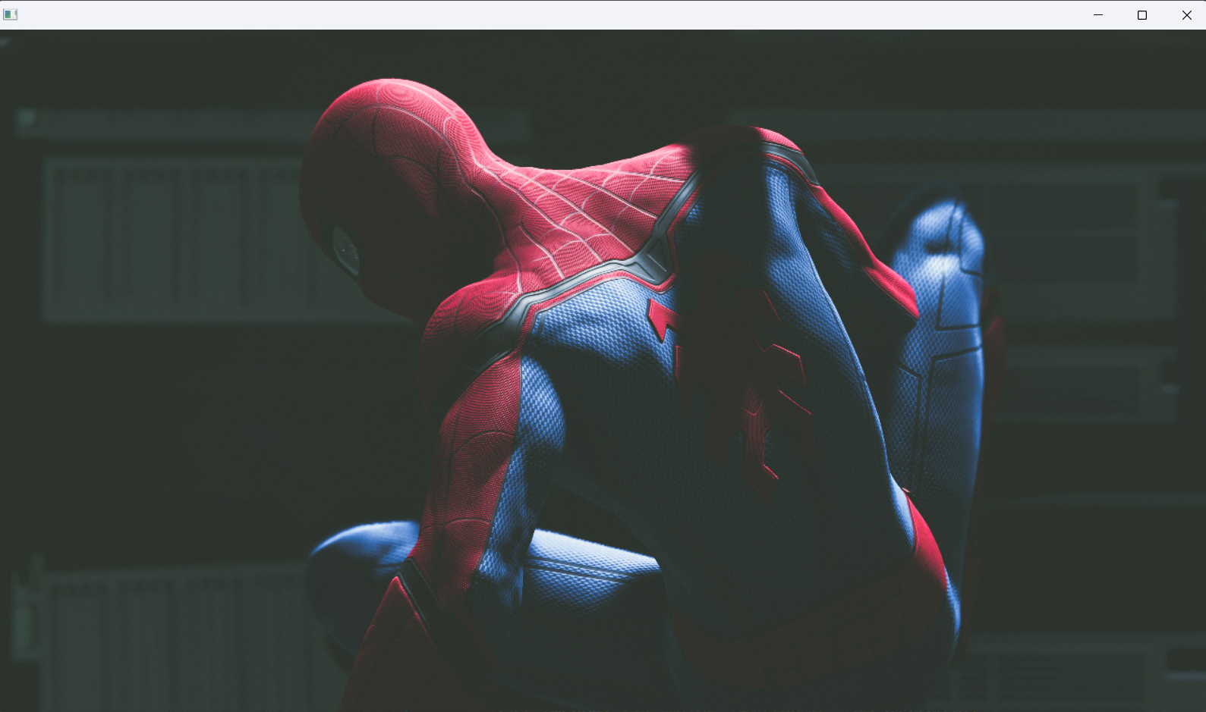

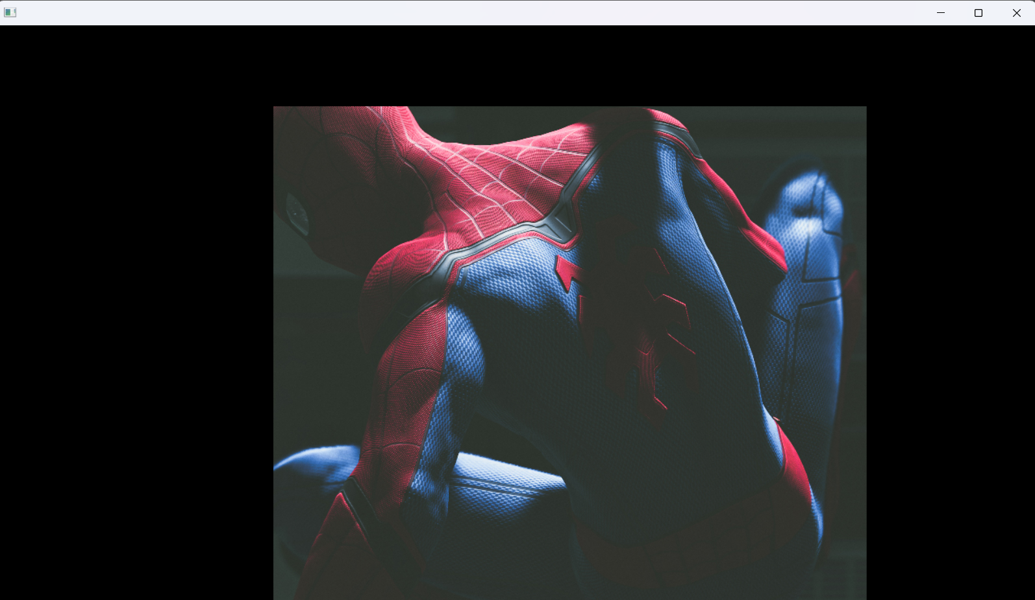

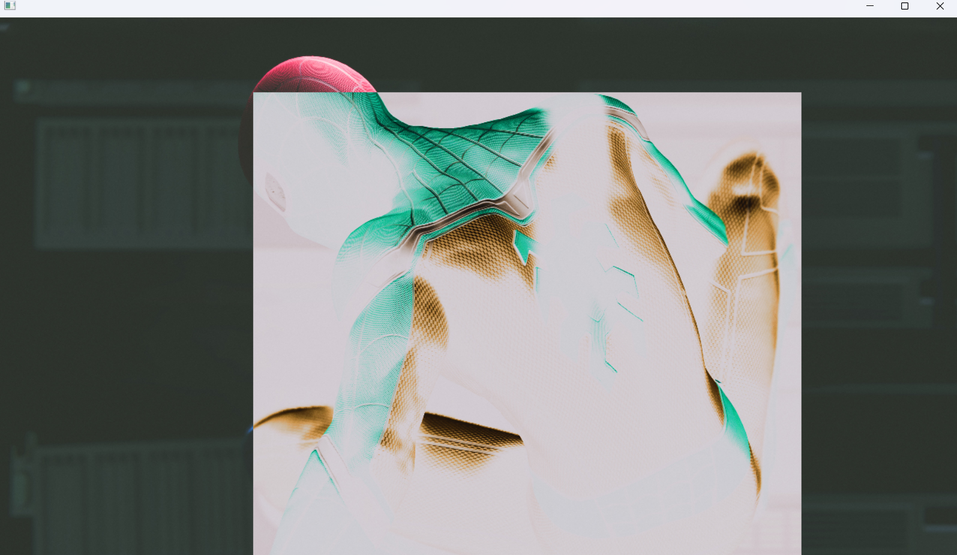

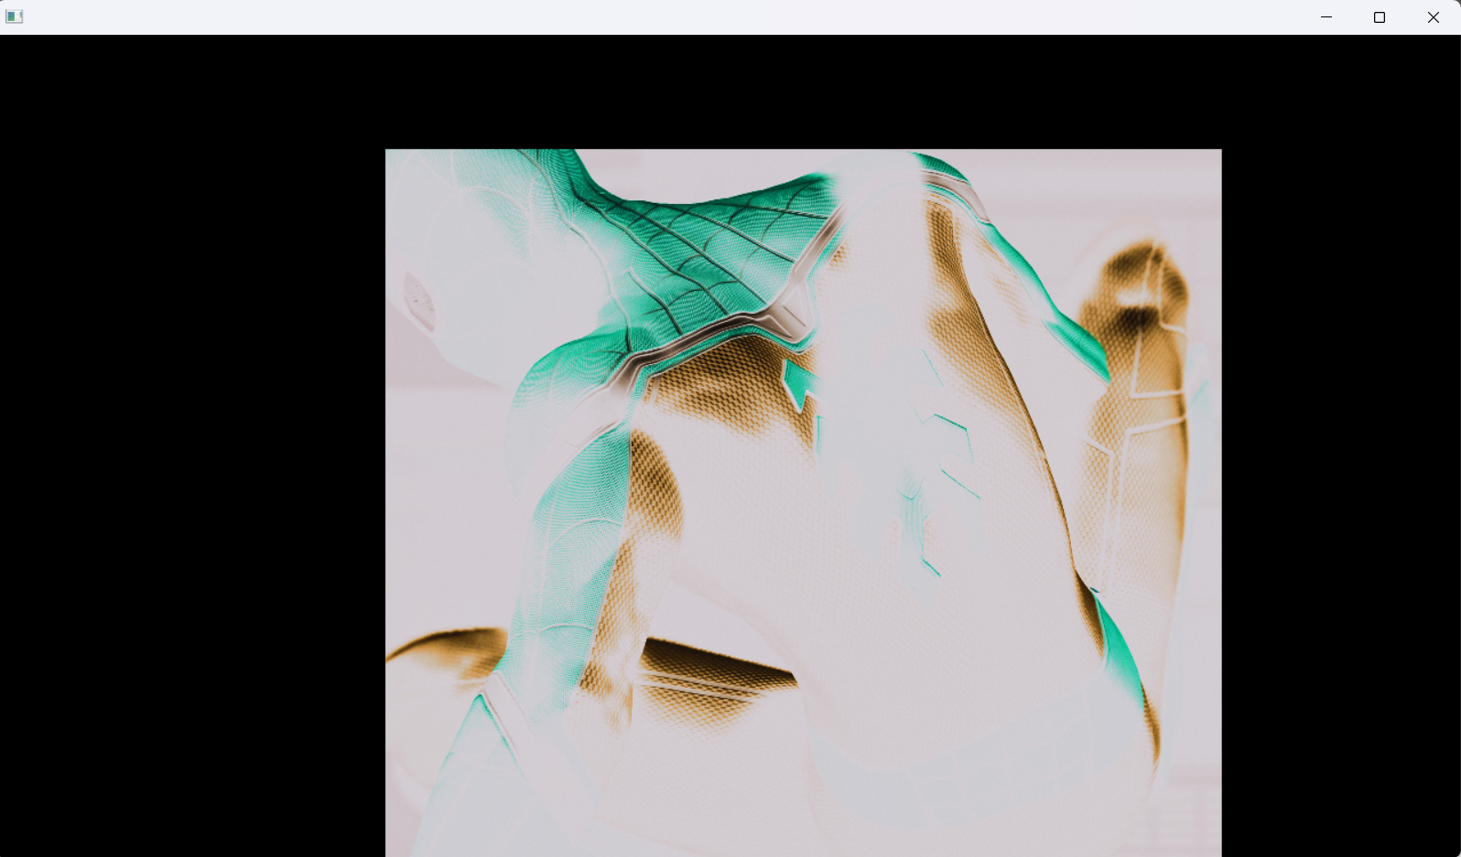

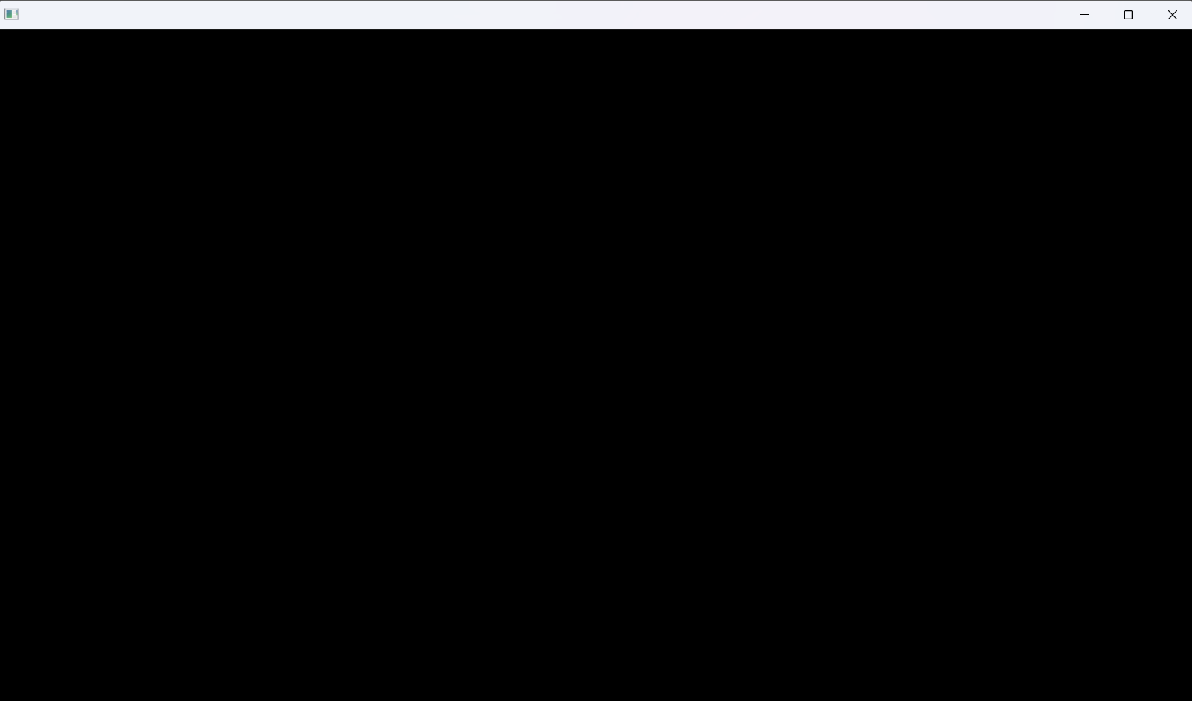

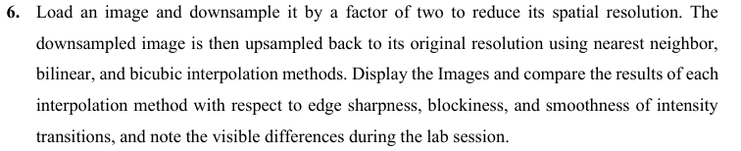

**Code:**

import cv2

img = cv2.imread('4278.jpg')

original_h, original_w = img.shape[:2]

down_size = (original_w // 2, original_h // 2)

downsampled = cv2.resize(img, down_size, interpolation=cv2.INTER_AREA)

up_nearest = cv2.resize(downsampled, (original_w, original_h), interpolation=cv2.INTER_NEAREST)

up_bilinear = cv2.resize(downsampled, (original_w, original_h), interpolation=cv2.INTER_LINEAR)

up_bicubic = cv2.resize(downsampled, (original_w, original_h), interpolation=cv2.INTER_CUBIC)

downsampled = cv2.resize(downsampled, (1280, 720))

cv2.imshow('Downsampled (1/2 size)', downsampled)

cv2.waitKey(0)

up_nearest = cv2.resize(up_nearest, (1280, 720))

cv2.imshow('Upsampled: Nearest Neighbor', up_nearest)

cv2.waitKey(0)

up_bilinear = cv2.resize(up_bilinear, (1280, 720))

cv2.imshow('Upsampled: Bilinear', up_bilinear)

cv2.waitKey(0)

up_bicubic = cv2.resize(up_bicubic, (1280, 720))

cv2.imshow('Upsampled: Bicubic', up_bicubic)

cv2.waitKey(0)

cv2.destroyAllWindows()

**Output:**

# 

# 

# Critical Analysis:

* The creation of a binary circle image via coordinate-based logic demonstrated a fundamental understanding of spatial geometry and pixel-level manipulation in a digital grid.
* Through grayscale conversion and binary thresholding, the lab illustrated how intensity values directly impact the visibility and readability of synthetic text in varying backgrounds.
* The application of geometric transformations, specifically 60 degree rotation on a thresholded binary structure, highlighted how interpolation and matrix-based warping affect object boundaries.
* Experiments with weighted image blending and histogram equalization showcased essential contrast enhancement methods used to improve structural visibility in complex scenes.
* Finally, the comparative analysis of nearest-neighbor, bilinear, and bicubic interpolation during upsampling provided practical insight into the trade-offs between computational speed and edge sharpness.